



Assignment 2

MLB_11.01_09

**Online Teacher Trainer**

Software Process Modeling

**IT1060 – Software Process Modeling Semester 2**

**Year 01 Semester II**- **2023**

|  |  |
| --- | --- |
| **PROJECT ID** | MLB_11.01_09 |
| **CASE STUDY NAME** | Attending lectures |
| **CAMPUS/CENTER** | SLIIT/Malabe |

**Group Details:**

|  |  |  |
| --- | --- | --- |
|  | **Student Registration Number** | **Student Name** |
| **1** | IT22102782 | Afzal Ahamed A H |
| **2** | IT22149626 | Chandrasiri G A S D |
| **3** | IT22150448 | Kaushalya W M D S |
| **4** | IT22144430 | Liyanage N S |
| **5** | IT22153654 | Piranavan S |

**I hereby certify,**

🗹 The attached is our own work and no further changes will be made.

🗹 I have contributed to this assignment to the best of my ability.

And we understand,

🗹 I may be subject to student discipline processes in the event of an act of academic misconduct by us including an act of plagiarism or cheating

|  |  |  |  |
| --- | --- | --- | --- |
| **Student Name** | **Student Registration**  **Number** | **Date** | **Signature** |
| Kaushalya WMDS | IT22150448 | 24/04/2023 |  |



**IT1060 – Software Process Modeling Semester 2**

**Year 01 Semester II**- **2023**

|  |  |
| --- | --- |
| **PROJECT ID** | MLB_11.01_09 |
| **CASE STUDY NAME** | Attending lectures |
| **CAMPUS/CENTER** | SLIIT/Malabe |

**Group Details:**

|  |  |  |
| --- | --- | --- |
|  | **Student Registration Number** | **Student Name** |
| **1** | IT22102782 | Afzal Ahamed A H |
| **2** | IT22149626 | Chandrasiri G A S D |
| **3** | IT22150448 | Kaushalya W M D S |
| **4** | IT22144430 | Liyanage N S |
| **5** | IT22153654 | Piranavan S |

**I hereby certify,**

🗹 The attached is our own work and no further changes will be made.

🗹 I have contributed to this assignment to the best of my ability.

And we understand,

🗹 I may be subject to student discipline processes in the event of an act of academic misconduct by us including an act of plagiarism or cheating

|  |  |  |  |
| --- | --- | --- | --- |
| **Student Name** | **Student Registration**  **Number** | **Date** | **Signature** |
| Kaushalya WMDS | IT22150448 | 24/04/2023 |  |

**IT1060 – Software Process Modeling Semester 2**

**Year 01 Semester II**- **2023**

|  |  |
| --- | --- |
| **PROJECT ID** | MLB_11.01_09 |
| **CASE STUDY NAME** | Attending lectures |
| **CAMPUS/CENTER** | SLIIT/Malabe |

**Group Details:**

|  |  |  |
| --- | --- | --- |
|  | **Student Registration Number** | **Student Name** |
| **1** | IT22102782 | Afzal Ahamed A H |
| **2** | IT22149626 | Chandrasiri G A S D |
| **3** | IT22150448 | Kaushalya W M D S |
| **4** | IT22144430 | Liyanage N S |
| **5** | IT22153654 | Piranavan S |

**I hereby certify,**

🗹 The attached is our own work and no further changes will be made.

🗹 I have contributed to this assignment to the best of my ability.

And we understand,

🗹 I may be subject to student discipline processes in the event of an act of academic misconduct by us including an act of plagiarism or cheating

|  |  |  |  |
| --- | --- | --- | --- |
| **Student Name** | **Student Registration**  **Number** | **Date** | **Signature** |
| Kaushalya WMDS | IT22150448 | 24/04/2023 |  |

**IT1060 – Software Process Modeling Semester 2**

**Year 01 Semester II**- **2023**

|  |  |
| --- | --- |
| **PROJECT ID** | MLB_11.01_09 |
| **CASE STUDY NAME** | Attending lectures |
| **CAMPUS/CENTER** | SLIIT/Malabe |

**Group Details:**

|  |  |  |
| --- | --- | --- |
|  | **Student Registration Number** | **Student Name** |
| **1** | IT22102782 | Afzal Ahamed A H |
| **2** | IT22149626 | Chandrasiri G A S D |
| **3** | IT22150448 | Kaushalya W M D S |
| **4** | IT22144430 | Liyanage N S |
| **5** | IT22153654 | Piranavan S |

**I hereby certify,**

🗹 The attached is our own work and no further changes will be made.

🗹 I have contributed to this assignment to the best of my ability.

And we understand,

🗹 I may be subject to student discipline processes in the event of an act of academic misconduct by us including an act of plagiarism or cheating

|  |  |  |  |
| --- | --- | --- | --- |
| **Student Name** | **Student Registration**  **Number** | **Date** | **Signature** |
| Kaushalya WMDS | IT22150448 | 24/04/2023 |  |

**IT1060 – Software Process Modeling Semester 2**

**Year 01 Semester II**- **2023**

|  |  |
| --- | --- |
| **PROJECT ID** | MLB_11.01_09 |
| **CASE STUDY NAME** | Attending lectures |
| **CAMPUS/CENTER** | SLIIT/Malabe |

**Group Details:**

|  |  |  |
| --- | --- | --- |
|  | **Student Registration Number** | **Student Name** |
| **1** | IT22102782 | Afzal Ahamed A H |
| **2** | IT22149626 | Chandrasiri G A S D |
| **3** | IT22150448 | Kaushalya W M D S |
| **4** | IT22144430 | Liyanage N S |
| **5** | IT22153654 | Piranavan S |

**I hereby certify,**

🗹 The attached is our own work and no further changes will be made.

🗹 I have contributed to this assignment to the best of my ability.

And we understand,

🗹 I may be subject to student discipline processes in the event of an act of academic misconduct by us including an act of plagiarism or cheating

|  |  |  |  |
| --- | --- | --- | --- |
| **Student Name** | **Student Registration**  **Number** | **Date** | **Signature** |
| Kaushalya WMDS | IT22150448 | 24/04/2023 |  |

**IT1060 – Software Process Modeling Semester 2**

**Year 01 Semester II**- **2023**

|  |  |
| --- | --- |
| **PROJECT ID** | MLB_11.01_09 |
| **CASE STUDY NAME** | Attending lectures |
| **CAMPUS/CENTER** | SLIIT/Malabe |

**Group Details:**

|  |  |  |
| --- | --- | --- |
|  | **Student Registration Number** | **Student Name** |
| **1** | IT22102782 | Afzal Ahamed A H |
| **2** | IT22149626 | Chandrasiri G A S D |
| **3** | IT22150448 | Kaushalya W M D S |
| **4** | IT22144430 | Liyanage N S |
| **5** | IT22153654 | Piranavan S |

**I hereby certify,**

🗹 The attached is our own work and no further changes will be made.

🗹 I have contributed to this assignment to the best of my ability.

And we understand,

🗹 I may be subject to student discipline processes in the event of an act of academic misconduct by us including an act of plagiarism or cheating

|  |  |  |  |
| --- | --- | --- | --- |
| **Student Name** | **Student Registration**  **Number** | **Date** | **Signature** |
| Kaushalya WMDS | IT22150448 | 24/04/2023 |  |

**Part 1**

|  |  |  |
| --- | --- | --- |
| **IT22150448** | | |
| **Use case ID** | OTT02 | |
| **Use case Name** | Attending lectures | |
| **Summary** | Attending enrolled modules’ lectures | |
| **Priority** | 1 | |
| **Preconditions** | User should registered to the system | |
| **Primary Actor(s)** | Trainee Teacher | |
| **Trigger** | The user wanted to get trained through online training system | |
| **Main Scenario** | **Step** | **Action** |
| **1** | User selects ‘Enroll Module’ option. |
| **2** | System display course(s) selected by the user. |
| **3** | User clicks on ‘Enroll Module’. |
| **4** | System asks user to enter module code. |
| **5** | User enters module code. |
| **6** | System enroll user to the selected module. |
| **7** | System displays module details, lecture notes, lecture videos and links. |
| **8** | User chooses lecture video(s) which he/she wanted to attend. |
| **9** | Download lecture notes, watch videos, attending live lectures. |
| **10** | Complete module. |
| **Extensions** | **Step** | **System Action** |
| **5a** | If module code is incorrect, system asks user to re-enter the code. |
| **Open Issues** | **-** | - |

**Part 1 – (2)**

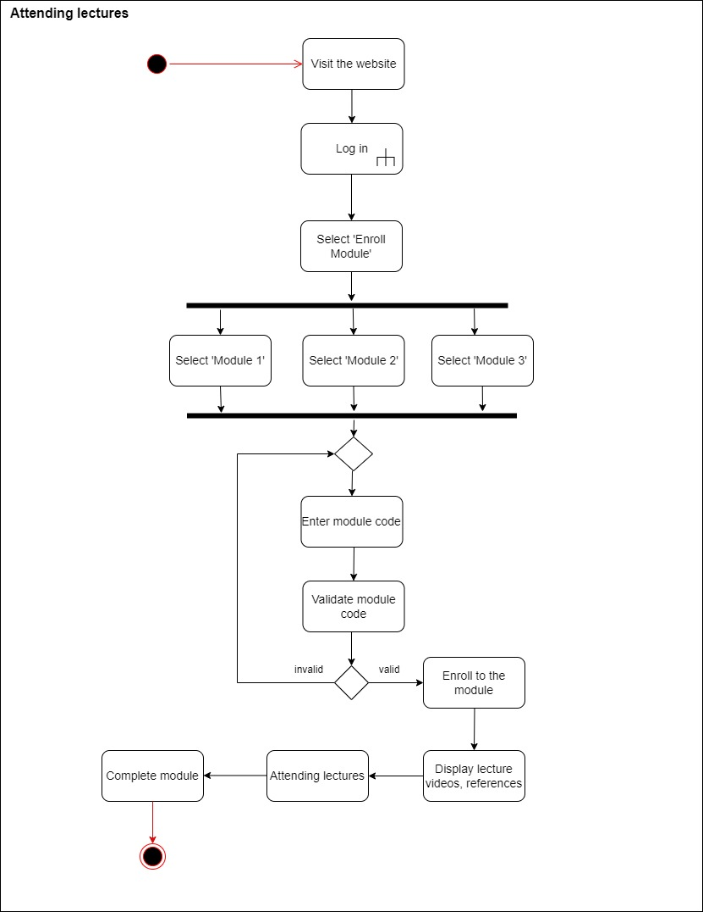

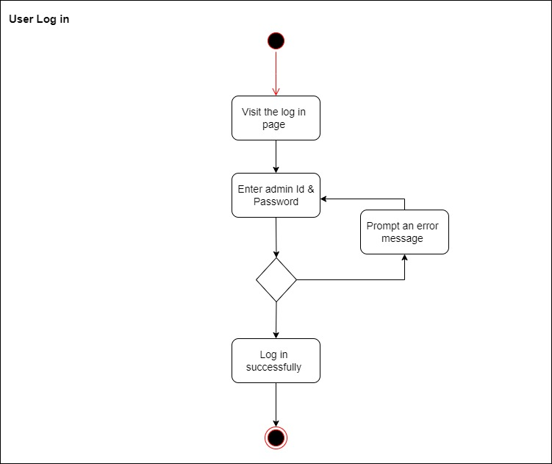

**Part 2**

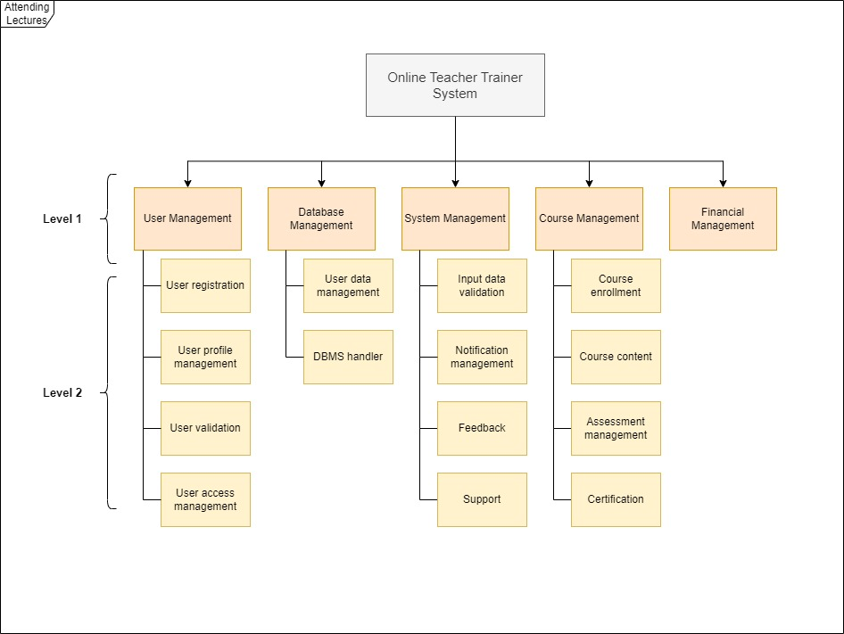

**Part 2 – (2)**